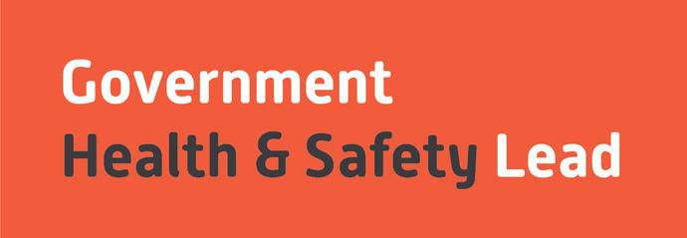

GOVERNMENT

HEALTH & SAFETY LEAD

**INTERN RECRUITMENT GUIDE**

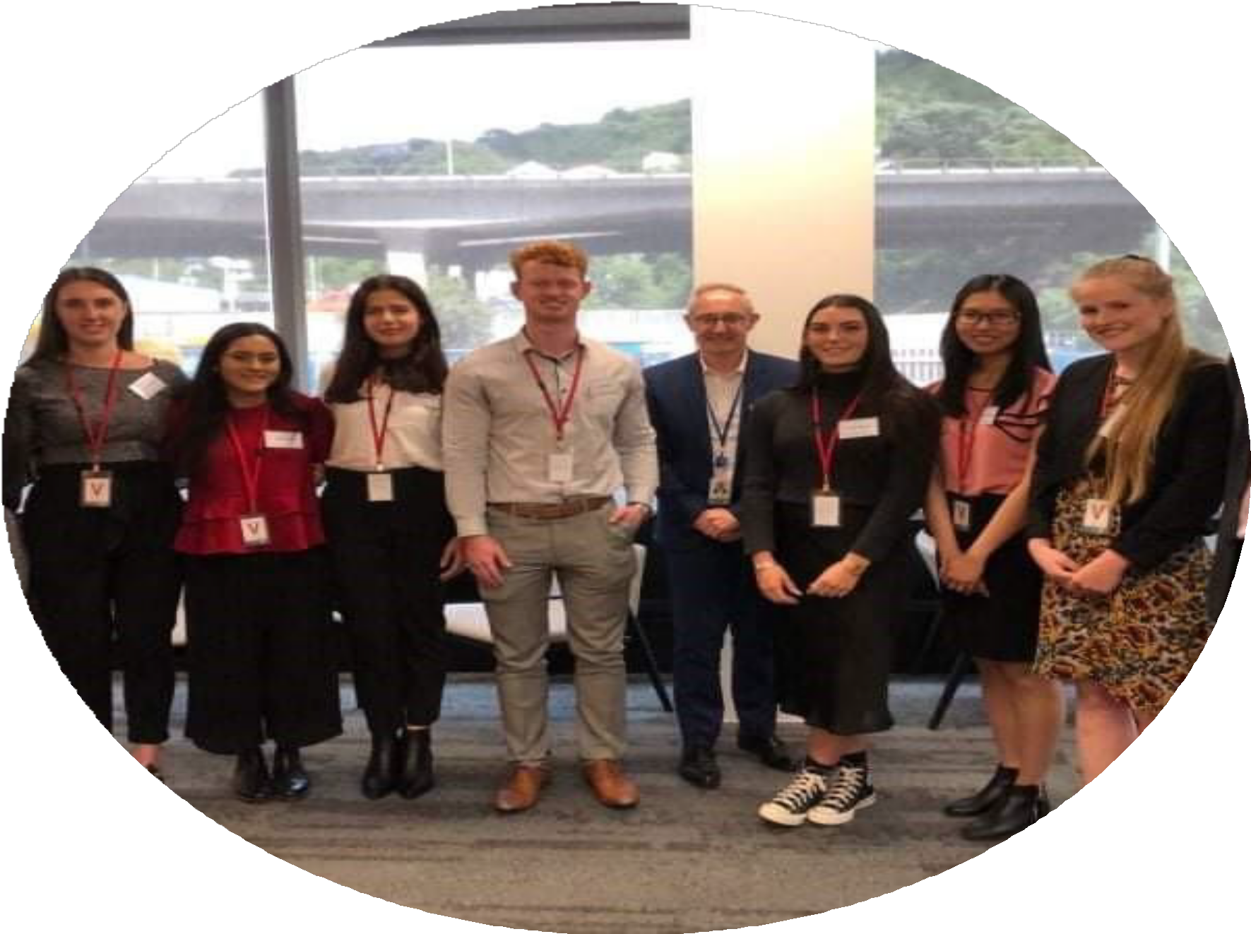

**CONTACT US**

**Government Health and**

**Safety Lead**

**Phone: 0800 HS LEAD (0800 47 5323)**

**Email:** [**ghsl@mpi.govt.nz**](mailto:ghsl@mpi.govt.nz)

**Showcasing Health, Safety and Wellbeing Careers across the Public Sector**

**This guide provides you with an overview of what our expectations are of our interns and what you can expect from the programme.**

**Our Summer Health, Safety, and Wellbeing Internship Programme presents an excellent chance to explore a career in health, safety, and wellbeing within the public sector.**

**Gain practical experience and insights into the work that our agencies health, safety, and wellbeing teams engage in. Previous interns have found the programme supported them to make a smoother transition from university into the business world.**

[**www. healthandsafety. govt. nz**](https://www.healthandsafety.govt.nz/careers-and-development/health-and-safety-summer-intern-programme/frequently-asked-questions-faqs-health-and-safety-intern-programme%20to)

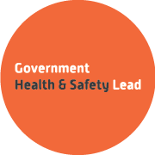

**CONTENTS**

Introduction. 3

About the Programme. 4

Programme Structure. 5

Why apply for the programme. 6

The Recruitment Process. 7

What are we looking for? 8

The 2025/26 Agencies placements information. 9

### WHO ARE THE GOVERNMENT HEALTH AND SAFETY LEAD?

The Government Health and Safety Lead team (GHSL) works with fifty-two public sector agencies* (which also includes departmental agencies, crown entities, state owned enterprises and other various organisations) to strengthen health and safety performance at an individual agency level, and collectively across the public sector.

As a small team of four, based within the Ministry for Primary Industries we are also tasked with providing both strategic and practical support to agency Chief Executives and senior leaders to enable their leadership of health and safety for the benefit of all New Zealanders.

The GHSL is responsible for coordinating the recruitment and delivery of the summer internship programme on the behalf of host agencies participating that year. The cohort can be based across the country depending on where the host agencies want their placements to be located. We are also, the main point of contact for all programme events. During the whole internship programme you will be provided with support, help and guidance from the GHSL, your host agency and manager.

For more information about us check out our website [www.healthandsafety.govt.nz](http://www.healthandsafety.govt.nz/)

Our Health and Safety Summer Intern Programme is a key part of the Government Health and Safety Lead (GHSL) workforce development programme, designed to support and provide a pipeline of future passionate health, safety, and wellbeing professionals for the public sector.



**ABOUT OUR PROGRAMME**

This three-month programme provides a mixture of on-the-job work experience, showcasing health and safety work across government through field trips and organised events coupled with informative workshops to develop core health, safety and wellbeing skills.

The programme highlights the importance of Health, Safety and Wellbeing (HSW) in New Zealand and the careers opportunities available in the profession.

Programme details:

•Recruitment starts on 31 July until midnight 15

August 2025

•Programme runs from 18 November 2025 to 13

February 2026

•Interns may be based anywhere the host agencies

are located.

•Interns are employed up to 14 weeks on fixed term full time contracts. (This duration can be extended past the intern programme dates if both parties agree).

•Interns will receive $29.20 per hour (as per Living

Wage 1/9/2025).

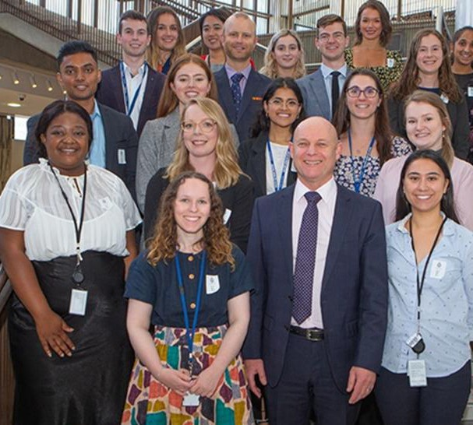

**Interns with Ray Smith, Director-General Ministry for Primary Industries at an event at Parliament**

**PROGRAMME AIM**

Our aim for our Summer Intern programme is to ‘showcase health, safety and wellbeing as a potential career for students within the public sector.’

This will be achieved by all our interns being offered placements within a Health, Safety and Wellbeing team within a government agency.

By the end of our programme, we expect all our interns to have achieved:

•An understanding of why health, safety and wellbeing is important, particularly as a function within an agency.

•Gain work experience to increase your skills in health, safety, and wellbeing within a diverse and interesting organisation.

•Understand the breadth and complexities of health, safety, and wellbeing within the government context.

•Directly contribute to a valuable health, safety and wellbeing project or work programme.

•Connect with like-minded professionals in the health, safety and wellbeing sector to build your own professional network.

### Our intern programme has three main components:

##### Valuable work experience

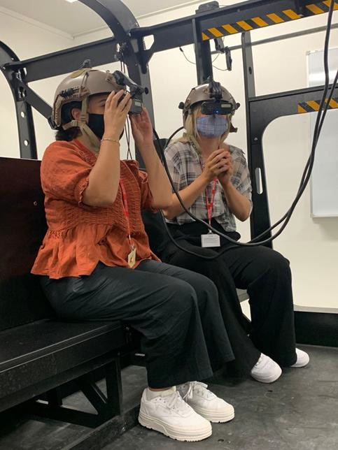The internship program offers valuable work experience in Health, Safety and Well-being (HSW) teams, with interns being paid the living working wage on a fixed term contract of employment.

The program is designed to provide interns with practical work experience where they will work alongside their HSW colleagues, on key health, safety and wellbeing priorities, team events, and you may be asked to contribute to programmes of work or small projects to be completed by the end of the internship programme.

At the end of the programme, interns will have relevant on the job experience which can be applied for entry level roles in health, safety and wellbeing enabling them to stand out from the competition and successfully transition into the workforce.

##### Workshops, field trips and practical learning

Interns are given the opportunity to attend a schedule of activities, networking events and field trips to enable interns to gain insights into a range of contexts where health and safety is applied. Our field trips are an invaluable source of learning to bring HSW to life, showing how their theoretical knowledge can be applied to real-life workplace day-to-day situations e.g., managing risks, hazard identification, and overlapping duties.

**Intern event at Ohakea New Zealand Airforce Base**

##### Connecting with others to build professional networks

The GHSL provides a forum for interns to connect with one-

another and to build relationships and networks which look like:

•Encouraging interns to go for lunch/coffee

•Attend speaker events with HSW Leaders from across the

public sector

•Collaborate on similar intern projects

•Attend social events with GHSL interns from prior cohorts to

learn about their experiences.

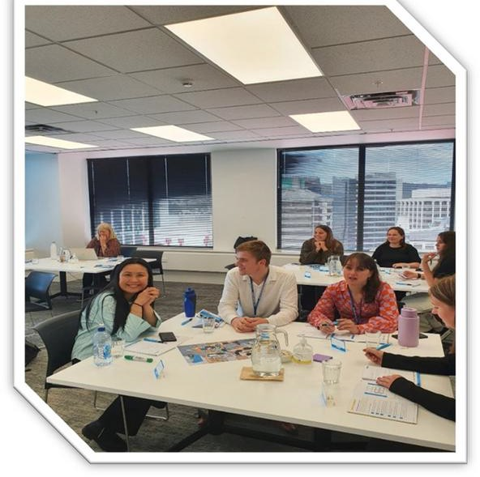**Interns Bailey and Zung attending an external workshop.**



**PROGRAMME STRUCTURE**



**Don't take our word for it, listen to what our interns have to say at** [**https://www.healthandsafety.govt.nz/careers-**](https://www.healthandsafety.govt.nz/careers-and-development/health-and-safety-summer-intern-programme/)[**and-development/health-and-safety-summer-**](https://www.healthandsafety.govt.nz/careers-and-development/health-and-safety-summer-intern-programme/)[**intern-programme**](https://www.healthandsafety.govt.nz/careers-and-development/health-and-safety-summer-intern-programme/)**/**

“I did not know my degree could lead to a career in Health, Safety and Wellbeing, I just thought the programme sounded like a great opportunity to put my psychology theory into practice. And that is all you need – to find something which interests you, and you might be surprised to see just how relevant your studies will be to your work.” Zung



**OUR RECRUITMENT PROCESS**

We will start recruiting from 31 July to 17 August 2025.

Our recruitment and selection process enables us to identify the key attributes and skills our agencies are looking to select a health, safety, and wellbeing intern to join this programme. Here are the recruitment stages and approximate timelines:

#### From 31 July to 17 August 2025

On 15 August applications close - longlisting starts and can take-up to 1-2 weeks.

#### From 22 August to 27 August 2025

Video Interview - Shortlisted candidates will submit a short self-taped video interview.

### From 9 September to 16 September 2025

* Auckland based interviews – Auckland candidates will be asked to attend either a MS team  
  meeting or face to face meeting on the 9 September. This will involve answering a few questions and meeting your prospective hiring manager.
* Wellington based interviews – Wellington candidates will be asked to attend either a MS teams meeting or face to face meeting on the 16 September. This will involve answering a few questions and meeting your prospective hiring manager.
* Preferred Candidates will be notified on the week commencing 22 September. Agencies will contact their preferred candidates to start the reference check and/vetting procedures.

Reference Checks and Offers of Employment- Agencies will need to complete a vetting process for their preferred intern candidate before offers of employment are made.

### What are we looking for?

We do not expect our interns to have any prior health and safety knowledge or experience but relevant.

study and an interest and open mind in this field is a must. An ideal candidate will:

* Be studying in New Zealand toward a diploma or undergraduate degree in:
  + Health science, public health, psychology, occupational health and safety, Māori or Pacific health,

human resources, criminology, environmental science, or related fields

* Transitioning to their fourth/final year of undergraduate study or graduating, who have completed papers in a related area of study to health, safety, and wellbeing.
* Have a genuine interest in a career in Health, Safety & Wellbeing
* Demonstrate good communications skills.
* Be available full-time from mid-November to mid-February.
* Be eligible to live, study, and work in New Zealand.
* We especially encourage applications from those with diverse cultural backgrounds and/or identify as disabled or have lived experience with disability.



**OUR RECRUITMENT PROCESS CONTD**

### Submitting your application

To apply we will require a Curriculum Vitae (CV), covering letter and academic transcripts.

* Your covering letter is an excellent opportunity to showcase your skills and interests. So, when you are writing your covering letter here are some examples we would like to hear about:
* A bit about you, your interests
* What are you studying and why?
* What interests you in applying for this HSW programme?
* Do you identify with communities or iwi, any background or lived experiences of disability you wish to share?
* Do you have any agencies that you would prefer to work for? Why?
* Any volunteer or community work you have done. Or experience leading, coaching, or mentoring others – for example in a sports team, volunteer group, or academically.

We recommend that you read the summaries for each agency's placement on pages 9 to 10, to find out more about the host agencies teams and what their work programmes may focus on, working hours and locations. Consider whether you want to work in a smaller or larger agency? Smaller agencies can be just as fun and supportive as larger agencies.

Reflect on what skills or experience you want to achieve from your placement and how they would relate to your studies. Most of our teams will be working in the general health, safety and wellbeing space however, some programmes of work may include areas such as:

* Risk assessment and management,
* Writing communications or guides
* Wellness / wellbeing/Mental health/Psychosocial harm
* Data, insights, and reporting

Please remember that you can talk to us about what you need so let us have a chat/kōrero about what you need to feel supported in your application.

#### Why do you need this application information?

The information you provide will help us match you with the agency that best fits your interests and work experience needs. Whilst we will strive to match you with your preferred choices, you may be invited to apply for another agency placement if your selections are unavailable.

**Please note that we are unable to offer any travel or relocation expenses in relation to this programme.**

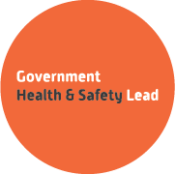

**2025/26 AGENCY PLACEMENTS**

# Internships on offer in Auckland = Two

# New Zealand Customs

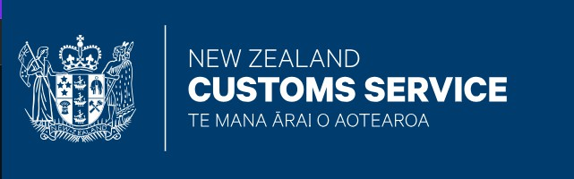

### Number of Placements: One

### Location - Auckland – Customs Head Office

This placement is based in the Health, Safety and Security team. Accessible by Public Transport: Yes.

##### What we do and why we do it?

The New Zealand Customs Service protects and promotes New Zealand through world class border management to protect New Zealand and advance our economy.

##### Your working arrangement:

Hybrid working model; however, you will be more office based than home based as you will be expected to support the team and go on site visits.

##### Here is a summary of the day-to-day duties our intern will be expected to complete:

We will provide a good Auckland orientation to the range of critical risks we have and how we manage those. We would like the intern to assist with a programme of work simplifying our online information for frontline staff re our critical risks so the intern will get exposure to:

* + Reality of the work
  + A view of critical risk and how they are managed.
  + Help us get something more accessible, funkier, and easier to find on the intranet and maybe some graphics as well if they have an aptitude.
  + Learning as an adjunct on how we lead and manage the wellbeing portfolio primarily experiential knowledge gain with some input from Senior Wellbeing Occupational Advisor.

##### Brief intro about the team, specific kōrero around what makes the team unique to work for?

We have a wide range of work history and backgrounds in high-risk areas. We are a cool team – down to earth and big backgrounds in a range of industries from clinical, health, disability sector to aviation, oil rig industry and maritime backgrounds.

Uniquely different but complementary skills and approach as a team. The team is lead from a place of genuine regard and all ideas in the mix and do not brook too much hierarchy. The team works extremely hard and are known for their professionalism and empathy as advisors.

We also enjoy our team time together with storytelling and tales of adventure and a fair amount of poetry and functional fitness on the easy side. All our interns have kept connected with us over the years and we take great interest in where their lives take them.

##### What specific skills or attributes we are looking for, in an intern?

Our intern must be able to pass our security vetting requirements, so you will need to be a NZ citizen or NZ resident for the minimum of five years.

We are also looking for someone who likes working with data analysis, can construct written arrangements from the user perspective. A curious personality that also shows respect and regard for the business and staff. Who is open to learn, works hard, self-starter who also likes a laugh.



**2025/26 AGENCY PLACEMENTS**

# Inland Revenue



### Number of Placements: One

### Location – Auckland – Manukau Office

This placement will be with the Health, Safety and Security team.

Accessible by Public Transport: Yes. Parking is also available in Westgate Shopping Mall.

##### What we do and why we do it - He aha ā mātou mahi, ā, he aha ai

Inland Revenue or Inland Revenue Department is the public service department of New Zealand charged with advising the government on tax policy, collecting and disbursing payments for social support programmes, and collecting tax.

##### About the team and our specific kōrero around what makes our team unique to work for?

Our team is Organisational Resilience, which covers the disciplines of health, safety, and wellbeing, along with business continuity and crisis management, as well as physical security. Scope for intern to have a bit of exposure to all areas within our team.

##### Your working arrangement:

We operate a hybrid working model and your role will be to work with the Safety, Health and Wellbeing team.

##### Here is a summary of the day-to-day duties our intern will be expected to complete:

Our intern will gain a broad understanding of the range of risks we manage, along with exposure to diverse areas of our work. They will contribute meaningfully by providing administrative support, which may include:

* Assisting in the development of internal resources
* Attending relevant meetings
* Managing an email inbox
* Reviewing and improving HSW related processes
* Contributing to the development of our risk management and control library
* Analysing existing incident data to identify trends and opportunities for improvement

##### What specific skills or attributes we are looking for, in an intern?

Our ideal intern will be interested in wellbeing health and safety and enthusiasm for learning.



**2025/26 AGENCY PLACEMENTS**

# Internship in Hawkes Bay = 1

# Unison



### Number of placements on offer: One

### Location – Hastings, Hawkes Bay

This placement is in the Health, Safety and Wellbeing team. Accessible by Public Transport: Yes.

##### What we do and why we do it - He aha ā mātou mahi, ā, he aha ai

E manaaki ana e matou ki te haumarutanga me te ora o to tatau iwi, whanau me ngā hapori.

We care for the safety and wellbeing of our people, families and communities.

Unison owns and manages the electricity distribution network in the Hawke’s Bay, Rotorua and Taupo regions, covering a service area of over 12,000 km2. Unison also provides electrical, civil, vegetation, network contracting services (Dunedin/Tauranga) and management services across the Group and in other regions across New Zealand. Our vision is simple but powerful: Together, we are leading a sustainable energy future.

##### About the team and our specific kōrero around what makes our team unique to work for?

We are a small, dedicated team who work hard to keep both our people and our communities safe. **Your working arrangement:**

You will be expected to work in the office and accompany the team on site visits. **Here is a summary of the day-to-day duties our intern will be expected to complete:**

Our intern will have a wide variety of tasks which will vary from day to day depending on need. You will be reporting to the Group H&S Manager plus providing support to the wider team. There will be days when you are in the office and days when you are out on site.

We achieve this through a strong, values-led culture grounded in:

* Safety & Wellbeing
* Excellence
* Customer Service
* Integrity
* Teamwork

Our small team which covers the disciplines of health, safety, wellbeing, and public safety as Unison has many thousands of assets out in the communities, we are part of.

##### What specific skills or attributes we are looking for, in an intern for this project or intern placement?

Our ideal intern would have a connection back to the Hawkes Bay, interested in wellbeing, health and safety and has an enthusiasm for learning. You will need to be adaptable, have a can-do attitude with a willingness to roll up their sleeves and help with anything.



**2025/26 AGENCY PLACEMENTS**

# Internships on offer in Wellington = 5

## Department of Corrections



### Number of Placements: One

### Location –Wellington central, Mayfair House

This placement is based in their Health, Safety and Wellbeing team. Accessible by Public Transport: Yes.

##### What we do and why we do it - He aha ā mātou mahi, ā, he aha ai

At Ara Poutama Aotearoa Department of Corrections, the purpose of our work is the wellness and wellbeing of people.

We are one of the leading government agencies in managing HS&W and one of the biggest with around 10,000 staff. We push for evidence based, cutting edge solutions to inform and constantly improve our practice to create a healthier and safer environment for our people. At Ara Poutama Aotearoa we have a large workforce who are exposed to many critical risks, eleven in total, some of which include psychological demands, violence and aggression, animals and biological hazards. Our Safety & Wellbeing function, of about sixty staff, support our leaders and workers to get home safe every day.

**Your working arrangement**: Both hybrid / office-based options are available.

**Here is a summary of the day-to-day duties our intern will be expected to complete:** Your daily tasks can vary but may include:

* Assisting with engagement of groups (unions/workers) to obtain feedback about health, safety and

wellbeing projects/artefacts

* Developing, design or assisting in the design of HS&W artefacts to be used by/for our front-line
* Implementing HS&W projects for user groups
* Assisting in the evaluation and continuous improvement of HS&W artefacts

##### What specific skills or attributes we are looking for, in an intern for this project or intern placement?

We know you will bring a whole pile of technical skills and be a motivated individual to learn and contribute. More than anything, what we want someone who will bring fresh ideas into our team. We want balance, diversity and different/new thinking. We are not necessarily looking for someone who thinks like us or is in line with our views. Instead, we want someone to challenge us, provoke thought and provide a difference, to achieve a better place for our people to work.



**2025/26 AGENCY PLACEMENTS**

### Ministry for Primary Industries

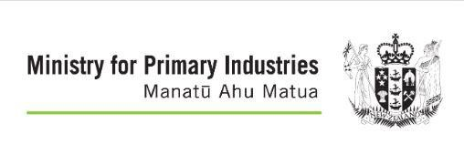

### Number of placements on offer: One

### Location - Wellington Central at Pastoral House

This placement is based in their Health, Safety and Wellbeing team. Accessible by Public Transport: Yes.

##### What we do and why we do it - He aha ā mātou mahi, ā, he aha ai.

The Ministry for Primary Industries is helping to seize export opportunities for our primary industries, improve sector productivity, ensure the food we produce is safe, increase sustainable resource use, and protect New Zealand from biological risk.

##### About the team and our specific kōrero around what makes our team unique to work for?

You will be joining the MPI’s central Health, Safety and Wellbeing (HSW) team that is passionate about collaborating and promoting continuous improvement in risk management across MPI. collaborating with a smaller team of four Advisers and an Administrator, reporting to the Manager HSW Strategy and Assurance.

As our intern you will have the opportunity to meet a wide of health and safety practitioners embedded across MPI’s business units. They will provide insight into how health and safety is managed in diverse environments such as farms, forests, beaches, ports, labs, transitional facilities and airports.

If you want to learn more about the depth and breadth of health and safety risk and understand how quality information contributes to improving health and safety outcomes, this is the internship for you.

We promise meaningful and interesting work, on-the-job experience, and an opportunity to gain insight into the day-to-day operations of a Health, Safety and Wellbeing team.

##### Your working arrangement:

Our intern will be expected to be office based and support the team on site visits.

##### Here is a summary of the day-to-day duties our intern will be expected to complete:

Our intern will be expected to assist the team and work with the Senior Advisor on a range of projects to be discussed at the start of your placement. You will also be asked to compete the following duties such as:

* Assisting in the development of internal resources
* Attending relevant meetings
* Managing an email inbox
* Reviewing and improving HSW related processes
* Contributing to the development of our risk management and control library
* Analysing existing incident data to identify trends and opportunities for improvement

##### What specific skills or attributes we are looking for, in an ideal intern.

Our ideal intern will have an interest in health, safety and wellbeing, health promotion, data analysis, good communication skills and is a team player.



**2025/26 AGENCY PLACEMENTS**

### Government Health and Safety and Lead

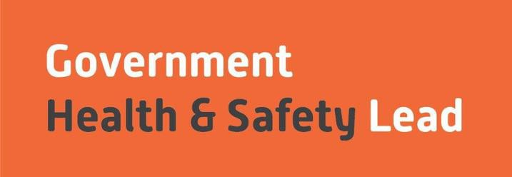

### Number of placements on offer: One

### Location – Wellington Central based in Pastoral House

This placement is with the team who are based in the Ministry for Primary Industries.

Accessible by Public Transport: Yes.

##### What we do and why we do it - He aha ā mātou mahi, ā, he aha ai

The GHSL works across fifty-two public service and other government agencies and is a small team of four.

We are tasked with providing practical support to chief executives, senior leaders and the health and safety teams of government agencies to enable their leadership of health and safety for the benefit of all New Zealanders.

##### About the team and our specific kōrero around what makes our team unique to work for?

The GHSL intern placement is unique as its not centered around gaining operational experience as you would within other placements, but instead you will gain an overview of how health and safety operates as a system across the public sector, including policy, communication and process development.

We are a small team of four who enjoy having a laugh as well as working hard.

##### Your working arrangement:

You will be expected to work from our head office.

##### Here is a summary of the day-to-day duties our intern will be expected to complete:

The GHSL intern will have a variety of day-to-day duties, where you will be supporting wider safety, health, and wellbeing initiatives, attending meetings, collaborating with other agencies and administrative work.

You will also assist the Principal Advisor in providing help at intern events, establishing and maintaining relationships with the other H&S interns within the cohort.

##### What specific skills or attributes we are looking for, in an intern for this project or intern placement?

Our ideal intern will be interested in wellbeing health and safety, research, reviewing information, be confidence to work with others and has a can-do attitude and an enthusiasm for learning.



**2025/26 AGENCY PLACEMENTS**

### Earth Sciences New Zealand (Previously GNS Science/Te Pū Ao)



#### Number of placements on offer: One

#### Location –Avalon, Lower Hutt, Wellington

This placement is in the Health, Safety and Wellbeing team.

Accessible by Public Transport: Yes.

##### What we do and why we do it - He aha ā mātou mahi, ā, he aha ai

As the agency transitions into Earth Sciences New Zealand — the merger of NIWA, GNS Science, and eventually Met Service, bringing together over 1,500 staff — we have a unique opportunity to combine the best elements of each organisation’s Health, Safety and Wellbeing (HSW) systems, frameworks, modules, policies, and procedures. Together, we can build a world-class HSW model for the future of ESNZ.

##### About the team and our specific kōrero around what makes our team unique to work for?

We are an experienced and collaborative team of seven, who are committed to continuous improvement, effective problem-solving, and building strong relationships.

We prioritise compliance and people safety in everything we do. Health, Safety and Wellbeing (HSW) is our core focus, and each team member brings a unique set of skills and perspectives that strengthen our collective impact.).

##### Your working arrangement:

You will be expected to work from our head office between the hours of 8am – 5pm. **Here is a summary of the day-to-day duties our intern will be expected to complete:**

This is an exciting opportunity for an intern to be part of that journey — gaining hands-on experience across all aspects of HSW, from office environments and laboratories to remote fieldwork across Aotearoa and around the globe.

Duties will include, but not limited to: Document Management & Review, internal audits, business partnerships and relationships, data management and analysis, investigations, compliance and systems review, risk assessments, training, systems management and analysis.

**What specific skills or attributes we are looking for, in an intern for this project or intern placement?** Our ideal intern will have good people skills and can work collaboratively as part of a team, be able to demonstrate strong data analysis skills, understand a regulatory compliance system, be experienced using software systems and high computer knowledge and have a can-do attitude and passion/interest in championing health, safety and wellbeing tasks.



**2025/26 AGENCY PLACEMENTS**

### Whaikaha /Ministry for Disabled People

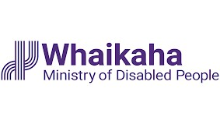

#### Number of placements on offer: One

#### Location –Wellington central

This placement will be in the Health and Safety team which is within the People and Capability team Accessible by Public Transport: Yes.

##### What we do and why we do it - He aha ā mātou mahi, ā, he aha ai

Whaikaha – Ministry of Disabled People was established to collaborate with the disability community, Māori, and government for a better, more independent future for disabled people and whānau in New Zealand.

##### About the team and our specific kōrero around what makes our team unique to work for?

All our kamahi must be able to establish credibility and trust and have empathy for the unique and diverse experiences of disabled people. We welcome applications from disabled people, or those who have a lived experience of disability through whānau or community involvement. Currently, just under 40% of our kaimahi identify as disabled people and we want this number to grow.

We care about the wellbeing and success of our people and provide a supportive and inclusive working environment where people can thrive and be who they really are. We are committed to the application of Te Tiriti o Waitangi in all levels of our work. We would love for you to enjoy our highly collaborative and supportive team on a wide variety of Wellbeing, health, and Safety tasks with an expectation that you will learn how a new public sector agency keeps its people safe.

##### Your working arrangement:

We offer flexible working, dedicated office and at home days based on the candidate’s preference.

##### Here is a summary of the day-to-day duties our intern will be expected to complete:

You will have an opportunity to be part of change, developing policy and processes that are fit for all our kaimahi, this will include emergency management processes and procedures, reviewing policies in place and participating and carry out consultation across the wider Whaikaha whānau across the mōtu. There will be some flexibility on what the candidate can choose to focus on, we are in the initial stages of developing our own Health and Safety structure and we want to be able to cater and develop key areas that are a focus for the individual. There is opportunity to be involved in the development of data analytics, the development of critical risks and controls.

Day to day duties include working in collaboration with the wider people and culture group, working across agencies with our host department the Ministry of Social development and the overall Wellbeing, health, and Safety work programme.

##### What specific skills or attributes we are looking for, in an intern for this project or intern placement?

We encourage applications from people of all backgrounds. We are looking for someone who can plan, organise, and communicate well, someone who enjoys working collaboratively in a team environment.

We offer a fully accessible working environment and can cater any additional needs the ideal candidate.

may have. Having a ‘can do’ attitude and the courage to ask ‘why not’ will be advantageous.